WEEK 7 ASSIGNMENT

Registration Screen
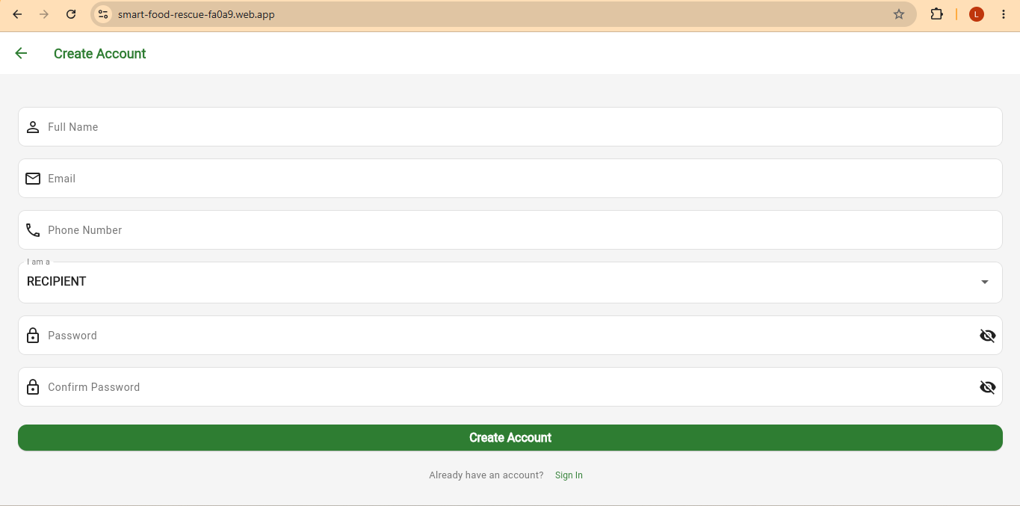
USERS DATABASE
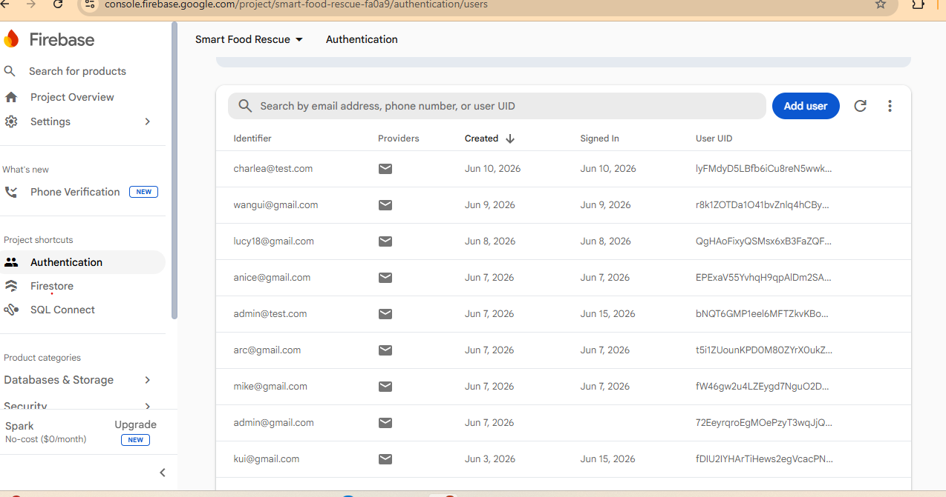

FIREBASE DATABASE
